In the last example, we saw how to retrieve parameter with **HttpServletRequest,** there is ways to get it by annotation as well.

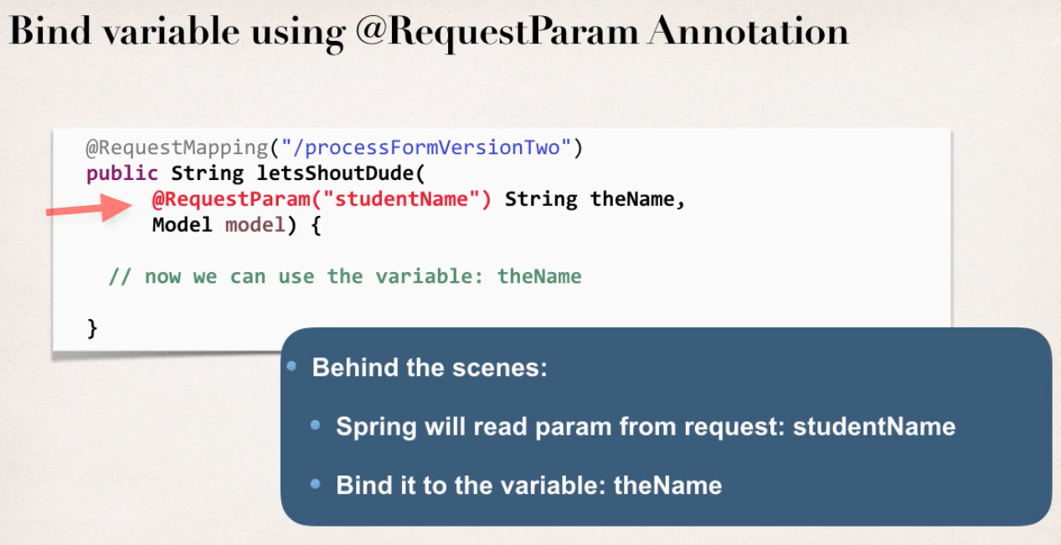

We can use **@RequestParam(“paramNameHere”)** annotation before a variable to get the data.

Below is two ways of getting param data with simple example.

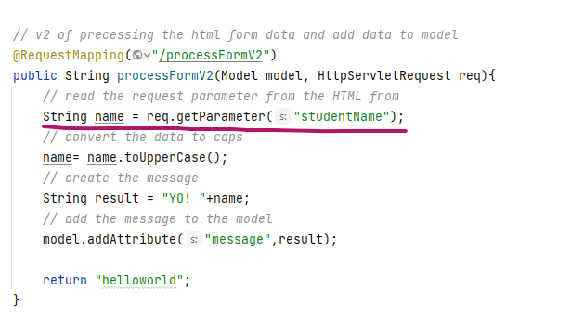

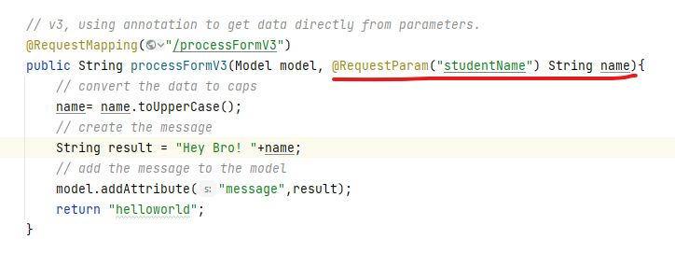

**Adding request mapping to controller:** We can add the request mapping in the controller level. Basically, it is multilevel URL mapping, kind of similar to middleware in the Node JS. express (maybe? Good chance of me being wrong here, have to see)

* All request mappings on methods are relative to controller’s folder path.

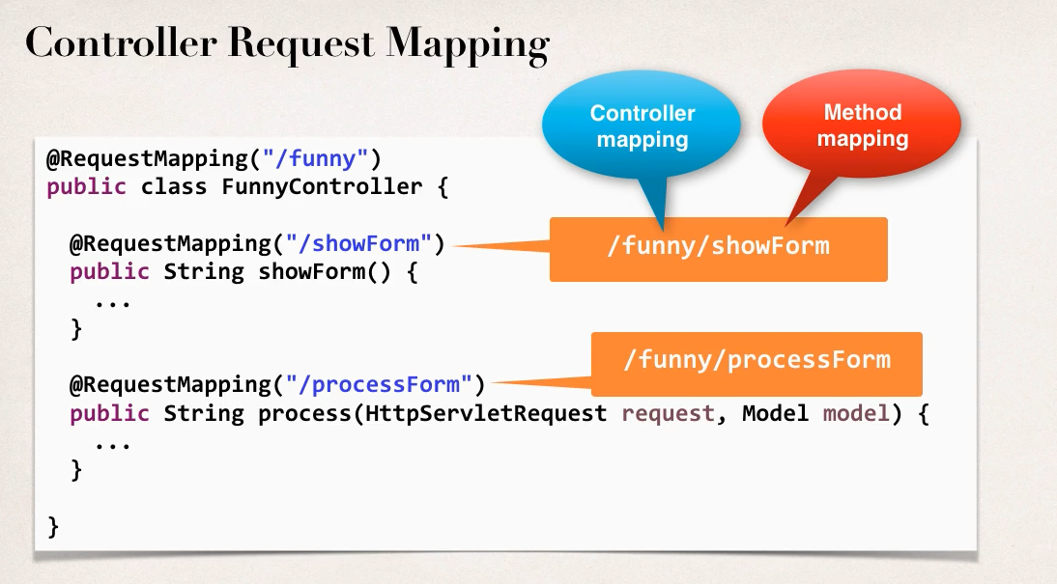

So, in this example, all requestion coming to **/funny** will be handled by FunnyController.

1. showForm will handle **/funny/showForm**
2. process will hand **/funny/processForm**